CUSTOM BOOTCAMP
PySpark

Big Data
- HDFS to store data in a distributed manner.
- Map Reduce to process the data.

Limitations in Hadoop
- Works on disk computation. The processing always happens on disk.
- Works only on batch data.
- If u want to do a SQL query, you must learn Hive.
- If u want to do _____, you must learn HBase.
- If u want to do _____, you must learn Pig.
- If u want to do ML, you must learn _____
- If u wan to handle real time, you must learn Apache Storm.

So, Berkeley developed Spark to do all the tasks in one application built on top of Hadoop. It kept HDFS as it is to store data but changed Map Reduce to Spark. It was 100 times faster. Made public in 2012. Project under Apache Foundation. 350+ projects are open source with non-profit organization Apache Spark. There are 5 languages in which Spark can be done. Spark can handle batch as well as real time data. You can do SQL queries in it.
Databricks is built on top of the Spark.

Forms of Big Data
- Structured
- Unstructured
- Semi-structured

Store, Process and Scale

- Monolithic System
- Distributed System

Resources
- RAM 16GB (Memory)
- Hard Disk 1TB (Storage)
- CPU Quad Core (Compute)

Hadoop 1.0
- HDFS for Distributed Storage
- Map Reduce for Distributed Processing

Big Data Tools
- Hadoop – Can only handle batch processing data.
- Apache Storm – Can only handle real time data.
- Apache Spark – Can handle both batch and real time data.

Apache Spark
- Spark can be considered as the success or of Hadoop as it overcomes the drawbacks of it. Spark, unlike Hadoop, both real-time as well as batch processing. It is a general-purpose clustering system.
- It also supports in-memory calculations, which makes it 100 times faster than Hadoop ………

Apache Spark unifies -
- Batch Processing
- Real Time Processing
- Stream Analytics
- Machine Learning
- Interactive SQL

Hadoop vs Spark
 | Hadoop | Spark
1 | Yahoo Project in 2006. | AMP Lab at UC Berkeley in 2012.
2 | Faster than traditional system. | 100 times faster than Hadoop.
3 | Lengthy and complex framework. | Simple and user-friendly system.
4 | Hadoop is designed to handle batch processing efficiently. | Spark is designed to handle both batch and real-time data efficiently.

Features of Spark
- Lightning-fast processing tool
- Ease of use
- Real-time stream processing
- Active and expanding community.

PySpark
Python + Spark = PySpark

Spark’s Basic Architecture
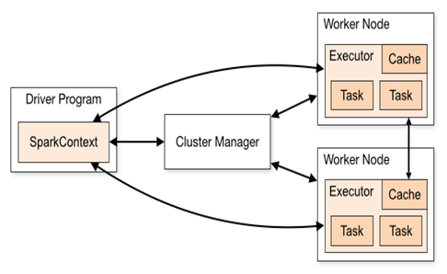

Cluster Manager
- Standalone – A simple cluster manager included with Spark that makes it easy to set up a cluster.
- F

- Kubernetes – An open-source system for automating deployment, scaling and management of containerized applications

Modes of Deployment
- Client Node:
- Cluster Node: Driver and executor on cluster
In local machine,

Spark’s Toolset

Resilient Distributed Dataset (RDD)
Spark RDD is resilient, partitioned, distributed, and immutable collection of data.
- Collection of Data: RDD hold data and appears to be a Scala collection.
- Resilient: RDD’s are fault tolerant
- Partition: Spark breaks the RDD into smaller chunks of data. These pieces are called partitions.
- Distributed: Spark distributes these partitions across the clusters.
- Immutable: Once defined, you can’t change them.

DataFrame
- A DataFrame is the most common Structured API and simply represents a table of data with rows and columns.
- Like a database table.
- The list that defines the columns, and the type within those columns is called the schema.

Spark Context
- It is the entry point of Spark functionality.
- It is used to communicate with cluster and to create RDD.
- The most important step of any Spark driver application is to generate Spark Context.
- It allows your Spark application to access Spark Cluster with the help of Resource Manager.
- The resource manager can be any of that ………

Note: You can create only one Spark Context per JVM, in order to create another you need to stop the existing one using stop() method.

Reading Schema in PySpark
When dealing with large datasets, using the "inferSchema" option can be time-consuming. In such cases, it's advisable to define your own schema using appropriate data types such as string, list, or PySpark data types. However, for datasets with nested data structures, relying solely on string and list types may not be suitable or effective.

